Exp -4 DML Commands with Constraints –UPDATE,
DELETE
1.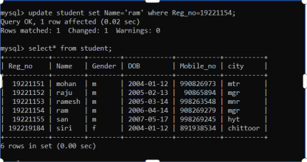
2.
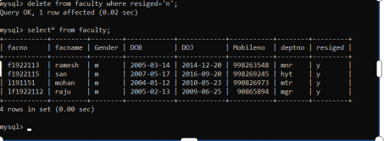
3.
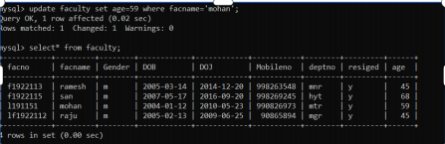
4.
